**AWS MINI PROJECT 1**

**­­**

**DONE BY**

**RANJITH KUMAR**

**Tasks to be performed:**

* **Hosting a website on EC2 instance using Auto scaling group, Application load balancer and Web application firewall.**
* **Monitoring using CloudWatch and adding Simple notification service to send notifications.**

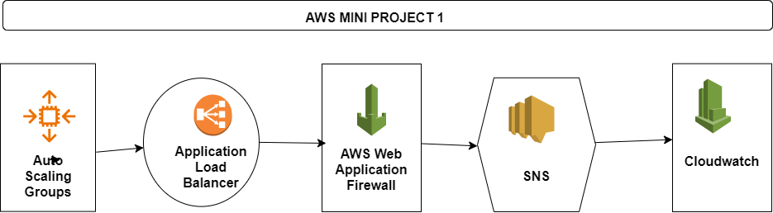

1.create a launch template

2.Select the necessary resources for the launch template and in additional settings > user data, Add the script to update and install on the EC2 instance when the instance starts

3.Launch template has been created

4.Create an Autoscaling group. Create an application load balancer & Target groups within the ASG itself. Configure the desired, minimum & maximum capacity also

5.Create a SNS topic within the ASG to send notifications to email when an event occurs.

6.ASG has been created

7.ALB with target groups, SNS topic with subscriptions has been created. Confirm the subscription received in the email.

8.We will be getting an email when the instance launch or any change in configuration of ASG

9.Access using the ALB DNS name

10.Create a web application firewall using AWS WAF service

11.First we need to create the IP sets

12.Give name, region, and ip address which need to be filtered using the WAF

13.Select the web ACL and associate the ALB with the WAF. Add the rules, set the rule priority, set cloudwatch the metrics

14.Web ACL has been created.

15.Now access the load balancer from the IP which we have mentioned in the IP sets.

16.We will get Forbidden message because it is blocked based on rules

17.Create a Cloudwatch dashboard to monitor the services

18.Added the widget, selected the metrics

19.Now we can monitor the performance of the system

